SUBJECT* | Boiler Regulator Repair

GENERAL INFORMATION
CONTRACTING OFFICE’S ZIP CODE* | 80111
SOLICITATION NUMBER* | 36C25926Q0021
RESPONSE DATE/TIME/ZONE | 11-12-2025 16:00 MOUNTAIN TIME, DENVER, USA
ARCHIVE | 30 DAYS AFTER THE RESPONSE DATE
RECOVERY ACT FUNDS | N
SET-ASIDE | SBA
PRODUCT SERVICE CODE* | J045
NAICS CODE* | 238220
CONTRACTING OFFICE ADDRESS | Department of Veterans Affairs  Network Contracting Office  NCO 19  6162 South Willow Drive, Suite 300  Greenwood Village CO 80111
POINT OF CONTACT* | Contract Specialist  Natasha Holland  natasha.holland@va.gov  303.712.5753
PLACE OF PERFORMANCE
ADDRESS | Department of Veteran Affairs
 | Eastern Colorado Healthcare System
 | Rocky Mountain Regional VAMC
 | 1700 N. Wheeling Street
 | Aurora CO
POSTAL CODE | 80045
COUNTRY | USA

ADDITIONAL INFORMATION
AGENCY’S URL
URL DESCRIPTION
AGENCY CONTACT’S EMAIL ADDRESS
EMAIL DESCRIPTION

DESCRIPTION
The purpose of this amendment 0003 is to clarify Question 2 (Q2) of Amendment 0002 of Request for Quote (RFQ) 36C25926Q0021, provide additional information, update Statement of Work (SOW) with new information, update CLINs and provide for an extension in quote submission.

- The deadline for quotes is hereby extended to November 12, 2025 at 16:00 MT

- Statement of work is attached please see updated SOW dated 11.7.2025

- Contractors shall acknowledge all amendments with quote submission and complete the updated CLIN structure.
The following CLIN structure must be completed
Line Item | Description | Unit of Measure | QTY | Unit Price | Total Price
0001 | Assess all gas regulator deficiencies and replace valves/parts as necessary | EA | 4 | $ | $
0002 | Regulators installation, boiler restart, and adjustments / retrofitting as required to return to fully operational status. | Job | 1 | $ | $
 |  |  |  | Grand Total | $

- The clarification to Q2 from Amendment 0002 is as follows:
Q2. Is there work that needs to be done on the gas train? If so, who provides specifics on whether Clever Brooks has to provide engineered drawings, or VA engineers due to the fact these boilers are specifically designed for the VA? Can we use our engineers and if so, who approves?
A2. Work on the gas train may be required if the replacement valve does not fit as it is already in place. Complete updated CLIN structure for work on gas train and installation as required because of the need to retrofit the new valve. Reengineered drawings aren’t required. All valves must be compatible with Cleaver Brooks Boiler System at the VA facility.
Flange-to-flange image of the gas pressure relief value and the measurement showing the distance (exact is just shy of 10 in. 9 15/16 in.)
See additional Pictures below:
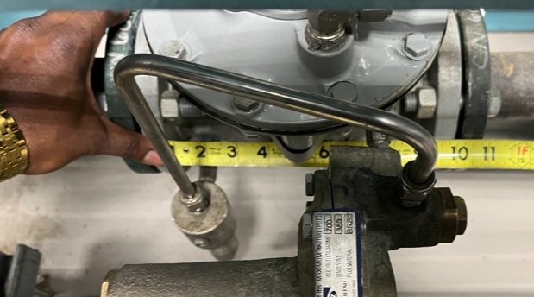
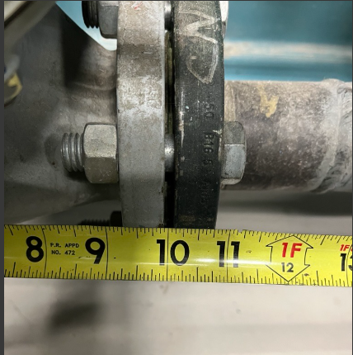
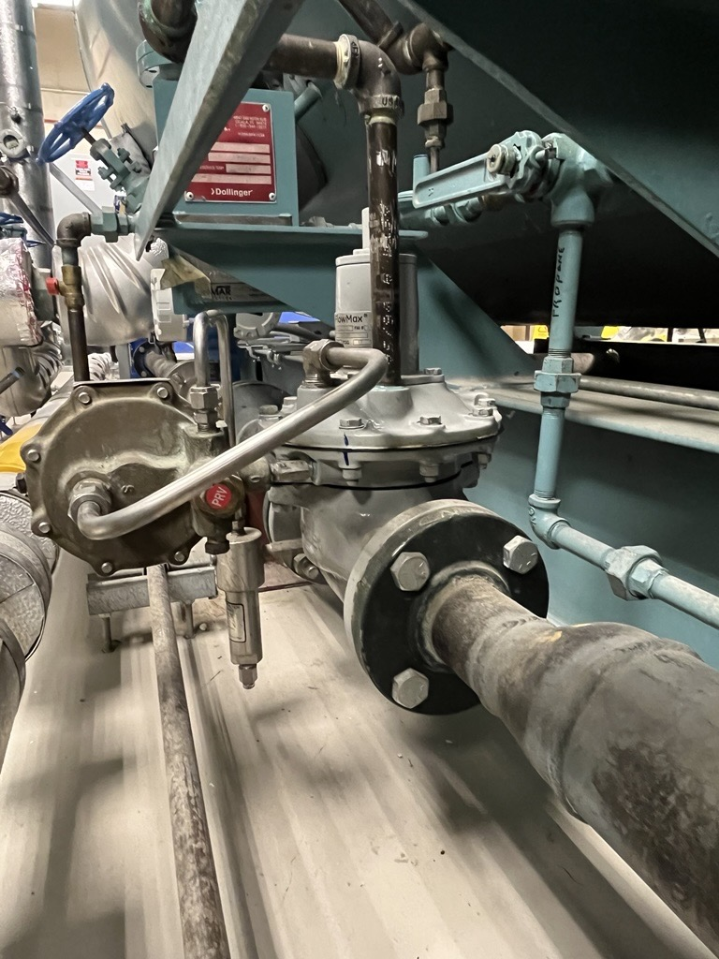
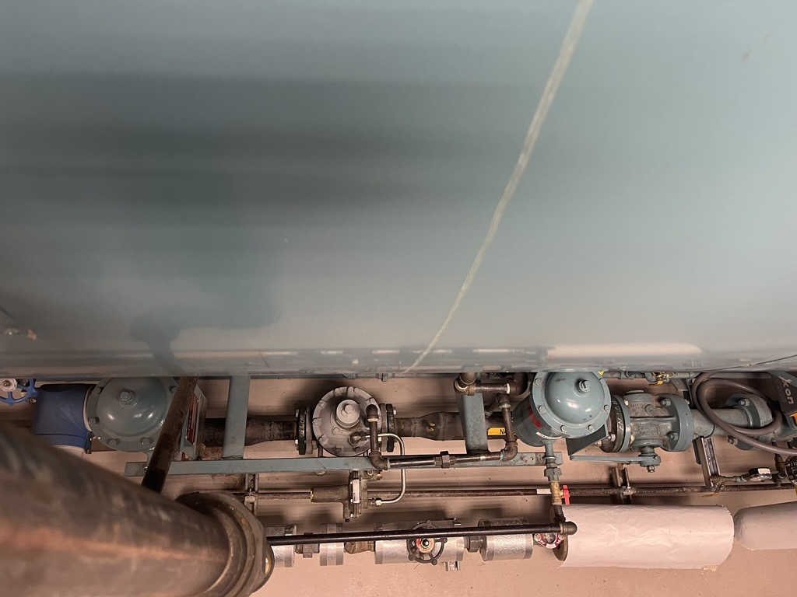
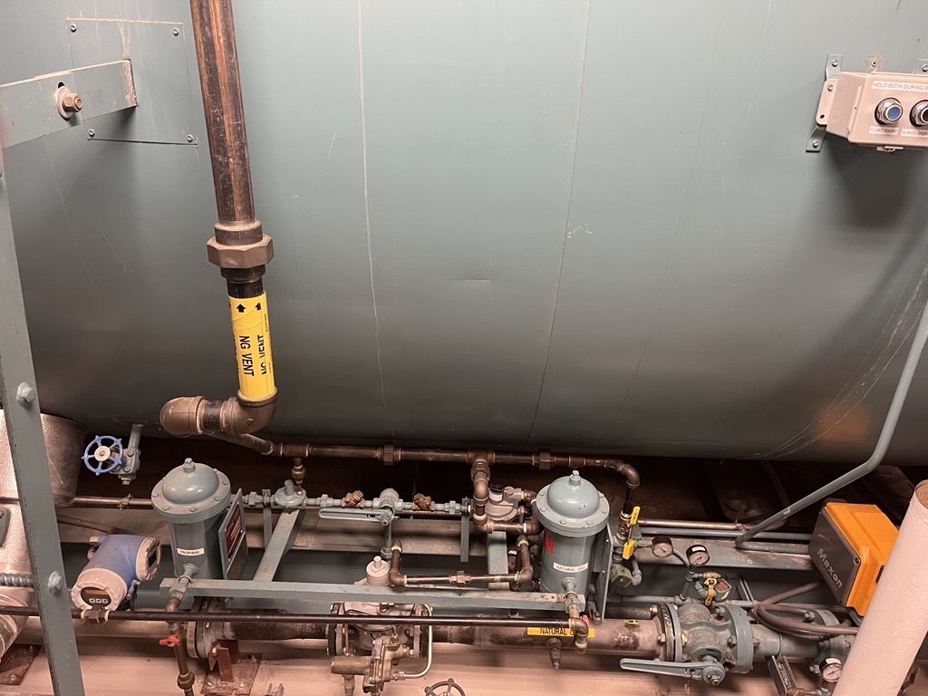

See attached document: P09_SOW Gas Regulator Valve_11.7.

